1、CAN帧类型

10 6 0

|  |  |  |  |  |  |  |  |  |  |  |
| --- | --- | --- | --- | --- | --- | --- | --- | --- | --- | --- |
| Frame Tag | | | | Node-id | | | | | | |
|  |  |  |  |  |  |  |  |  |  |  |

Node-id：节点id，7位，0~127

Frame Tag：帧类型

|  |  |  |  |
| --- | --- | --- | --- |
| 类型 | 值 | 功能 | 方向 |
| FRAME_CMD | 0x00 | HOST发起CMD操作（详见） |  |
| FRAME_ACK | 0x01 | DEVICE应答CMD指令 |  |
| FRAME_UPLOADh | 0x02 | HOST upload帧 |  |
| FRAME_UPLOADd | 0x03 | DEVICE upload帧 |  |
| FRAME_DOWNLOADh | 0x04 | HOST download帧 |  |
| FRAME_DOWNLOADd | 0x05 | DEVICE download帧 |  |
| FRAME_PRINTF | 0x06 | DEVICE打印输出信息到HOST |  |

2、CMD帧格式

|  |  |  |  |  |  |  |  |  |  |  |  |  |  |  |  |
| --- | --- | --- | --- | --- | --- | --- | --- | --- | --- | --- | --- | --- | --- | --- | --- |
| 仲裁域 | | 控制域 | | | 数据域 | | | | | | | | CRC及其他域 | | |
| STID/11 | RTR | IDE | R0 | DLC/4 | Data（8 bytes） | | | | | | | | CRC | ACK | EOF |
| 0x00+nodeid | 0 | 0 | 0 | length | CMD |  |  |  |  |  |  |  |  |  |  |

CMD类型

|  |  |  |  |
| --- | --- | --- | --- |
| 类型 | 值 | 功能 |  |
| CMD_READ_INFO | 0x01 | 读取Bootloader信息 |  |
| CMD_WRITE_INFO | 0x02 | 写Bootloader信息 |  |
| CMD_ERASE | 0x03 | 擦除flash |  |
| CMD_RUN | 0x04 | 运行用户程序 |  |

2.1 CMD_READ_INFO

|  |  |  |  |  |  |  |  |  |  |  |  |  |  |  |  |
| --- | --- | --- | --- | --- | --- | --- | --- | --- | --- | --- | --- | --- | --- | --- | --- |
| 仲裁域 | | 控制域 | | | 数据域 | | | | | | | | CRC及其他域 | | |
| STID/11 | RTR | IDE | R0 | DLC/4 | Data（8 bytes） | | | | | | | | CRC | ACK | EOF |
| 0x00+nodeid | 0 | 0 | 0 | 2 | 01 | option |  |  |  |  |  |  |  |  |  |

option：读取信息选项

|  |  |  |
| --- | --- | --- |
| 选项 | 值 | 内容 |
| INFO_FW_VERSION | ((uint8_t)0x01 << 0) | 固件版本 |
| INFO_FW_FLAG | ((uint8_t)0x01 << 1) | 固件是否更新成功标志 |
| INFO_FW_ADDRESS | ((uint8_t)0x01 << 2) | 固件起始地址 |
| INFO_FW_BYTE_NBR | ((uint8_t)0x01 << 3) | 固件大小（字节数） |

返回数据帧格式

|  |  |  |  |  |  |  |  |  |  |  |  |  |
| --- | --- | --- | --- | --- | --- | --- | --- | --- | --- | --- | --- | --- |
| 仲裁域 | | 控制域 | | | 数据域 | | | | | CRC及其他域 | | |
| STID/11 | RTR | IDE | R0 | DLC/4 | Data（8 bytes） | | | | | CRC | ACK | EOF |
| 0x01+nodeid | 0 | 0 | 0 | 6 | 01 | option | Info(4bytes) |  |  |  |  |  |

2.2 CMD_WRITE_INFO

|  |  |  |  |  |  |  |  |  |  |  |  |  |
| --- | --- | --- | --- | --- | --- | --- | --- | --- | --- | --- | --- | --- |
| 仲裁域 | | 控制域 | | | 数据域 | | | | | CRC及其他域 | | |
| STID/11 | RTR | IDE | R0 | DLC/4 | Data（8 bytes） | | | | | CRC | ACK | EOF |
| 0x00+nodeid | 0 | 0 | 0 | 6 | 02 | option | Info(4bytes) |  |  |  |  |  |

option 与CMD_READ_INFO一致

返回数据帧格式

|  |  |  |  |  |  |  |  |  |  |  |  |  |  |  |  |
| --- | --- | --- | --- | --- | --- | --- | --- | --- | --- | --- | --- | --- | --- | --- | --- |
| 仲裁域 | | 控制域 | | | 数据域 | | | | | | | | CRC及其他域 | | |
| STID/11 | RTR | IDE | R0 | DLC/4 | Data（8 bytes） | | | | | | | | CRC | ACK | EOF |
| 0x01+nodeid | 0 | 0 | 0 | 3 | 02 | option | ack |  |  |  |  |  |  |  |  |

2.3 CMD_ERASE

|  |  |  |  |  |  |  |  |  |  |  |
| --- | --- | --- | --- | --- | --- | --- | --- | --- | --- | --- |
| 仲裁域 | | 控制域 | | | 数据域 | | | CRC及其他域 | | |
| STID/11 | RTR | IDE | R0 | DLC/4 | Data（8 bytes） | | | CRC | ACK | EOF |
| 0x00+nodeid | 0 | 0 | 0 | 8 | 03 | Addr(4bytes) | Len(3bytes) |  |  |  |

返回数据帧格式

|  |  |  |  |  |  |  |  |  |  |  |  |  |  |  |  |
| --- | --- | --- | --- | --- | --- | --- | --- | --- | --- | --- | --- | --- | --- | --- | --- |
| 仲裁域 | | 控制域 | | | 数据域 | | | | | | | | CRC及其他域 | | |
| STID/11 | RTR | IDE | R0 | DLC/4 | Data（8 bytes） | | | | | | | | CRC | ACK | EOF |
| 0x01+nodeid | 0 | 0 | 0 | 2 | 03 | ack |  |  |  |  |  |  |  |  |  |

2.4 CMD_RUN

|  |  |  |  |  |  |  |  |  |  |  |  |  |  |  |  |
| --- | --- | --- | --- | --- | --- | --- | --- | --- | --- | --- | --- | --- | --- | --- | --- |
| 仲裁域 | | 控制域 | | | 数据域 | | | | | | | | CRC及其他域 | | |
| STID/11 | RTR | IDE | R0 | DLC/4 | Data（8 bytes） | | | | | | | | CRC | ACK | EOF |
| 0x00+nodeid | 0 | 0 | 0 | 1 | 04 |  |  |  |  |  |  |  |  |  |  |

返回数据帧格式(不成功时才会返回)

|  |  |  |  |  |  |  |  |  |  |  |  |  |  |  |  |
| --- | --- | --- | --- | --- | --- | --- | --- | --- | --- | --- | --- | --- | --- | --- | --- |
| 仲裁域 | | 控制域 | | | 数据域 | | | | | | | | CRC及其他域 | | |
| STID/11 | RTR | IDE | R0 | DLC/4 | Data（8 bytes） | | | | | | | | CRC | ACK | EOF |
| 0x00+nodeid | 0 | 0 | 0 | 1 | 04 | 00 |  |  |  |  |  |  |  |  |  |

3、download协议

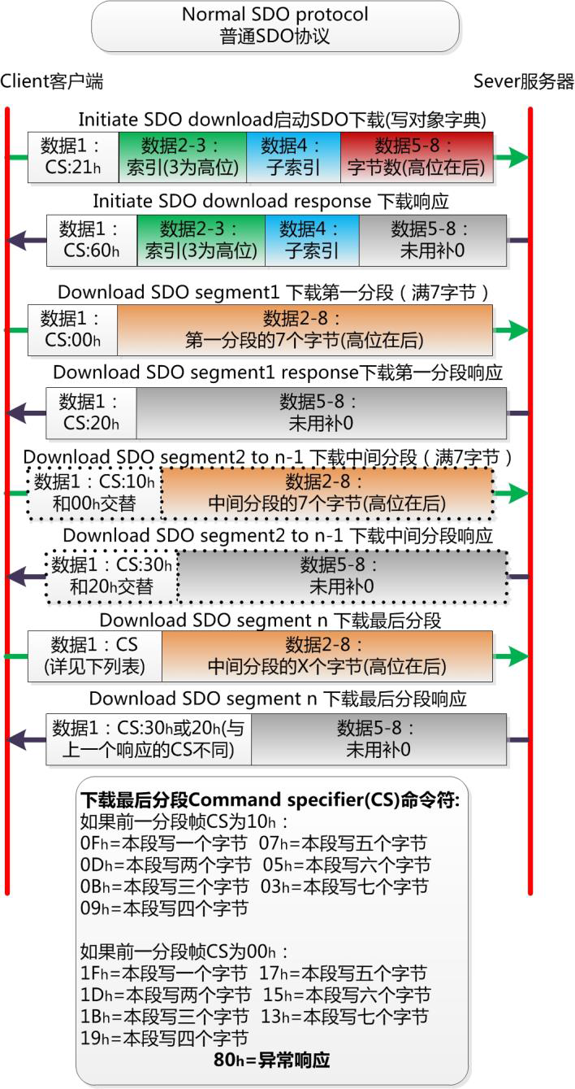

**数据6-8**

**字节数**

**数据6-8**

**字节数**

**数据2-5**

**Flash地址**

**数据2-5**

**Flash地址**

**DEVICE**

**HOST**

4、upload协议

**DEVICE**



**数据6-8**

**字节数**

**数据2-5**

**Flash地址**

**数据2-5**

**Flash地址**

**数据6-8**

**字节数**

**HOST**

5、流程

Bootloader主函数流程

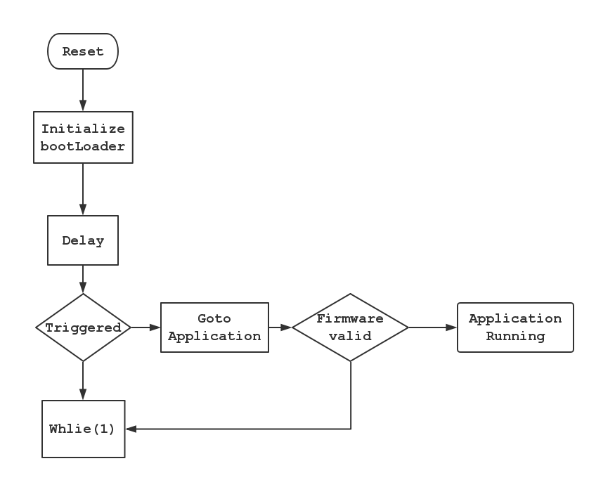

CAN接收中断

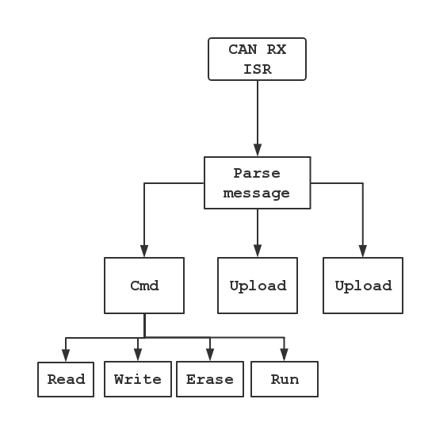

HOST循环广播搜索帧，DEVICE收到之后反馈自身id并置triggered位

搜索帧

|  |  |  |  |  |  |  |  |  |  |  |  |  |  |  |  |
| --- | --- | --- | --- | --- | --- | --- | --- | --- | --- | --- | --- | --- | --- | --- | --- |
| 仲裁域 | | 控制域 | | | 数据域 | | | | | | | | CRC及其他域 | | |
| STID/11 | RTR | IDE | R0 | DLC/4 | Data（8 bytes） | | | | | | | | CRC | ACK | EOF |
| 0xFF | 0 | 0 | 0 | 8 | 22 | 5A | 58 | 46 | 57 | 50 | 4D | 4A |  |  |  |

反馈帧

|  |  |  |  |  |  |  |  |  |  |  |  |  |  |  |  |
| --- | --- | --- | --- | --- | --- | --- | --- | --- | --- | --- | --- | --- | --- | --- | --- |
| 仲裁域 | | 控制域 | | | 数据域 | | | | | | | | CRC及其他域 | | |
| STID/11 | RTR | IDE | R0 | DLC/4 | Data（8 bytes） | | | | | | | | CRC | ACK | EOF |
| 0x80 | 0 | 0 | 0 | 1 | id |  |  |  |  |  |  |  |  |  |  |